Problem Statement: Set up a VPC with an Internet gateway, create a public subnet, a private subnet make a route table connecting the Internet gateway and the subnets, and launch a Linux EC2 instance by using the above vpc and public subnet.

Solution:

Go to VPC 🡪 Create VPC 🡪 Select “VPC and more” 🡪 Name the VPC

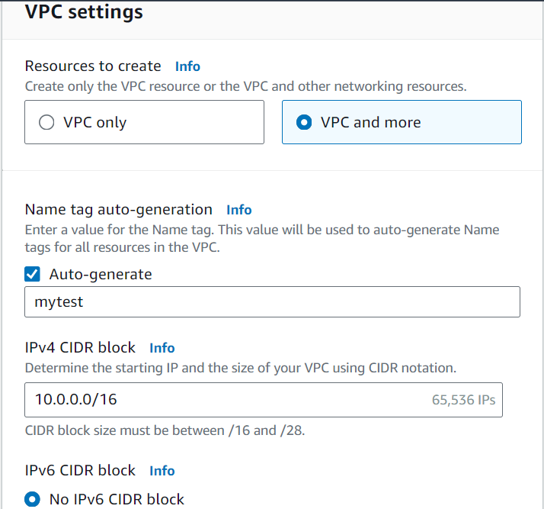

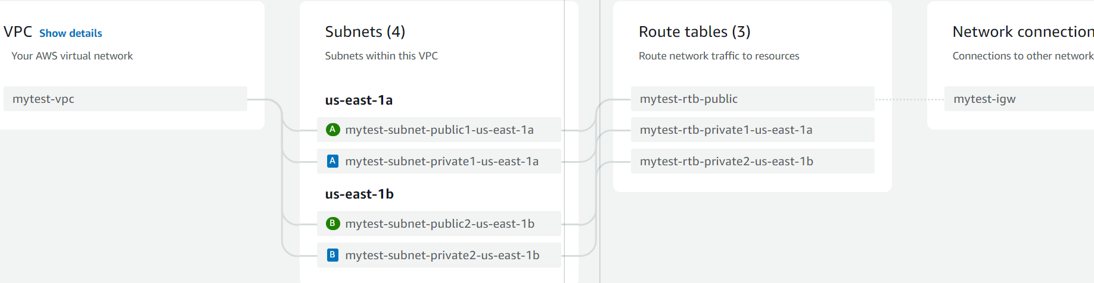

Select the configurations as below,

Number of availability zones: 2

Number of public and private subnets: 2

VPC Endpoint: None

After filling the configurations, click on Create VPC

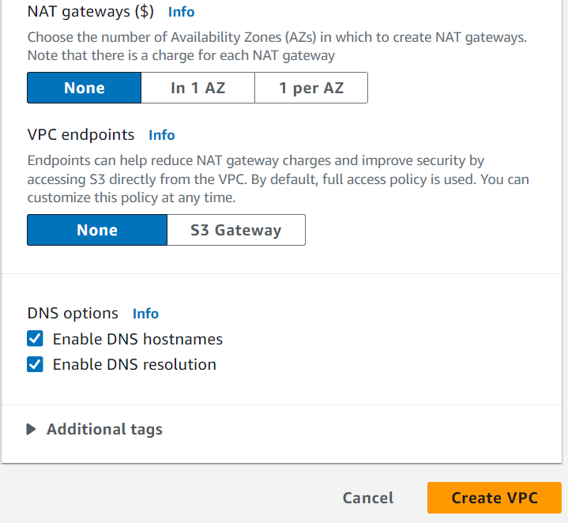

VPC is successfully created with an Internet gateway and route table configurations.

Now Launching the EC2 instance within the VPC:

Go to EC2 🡪 Launch Instance 🡪 Name the Instance 🡪 Select the AMI

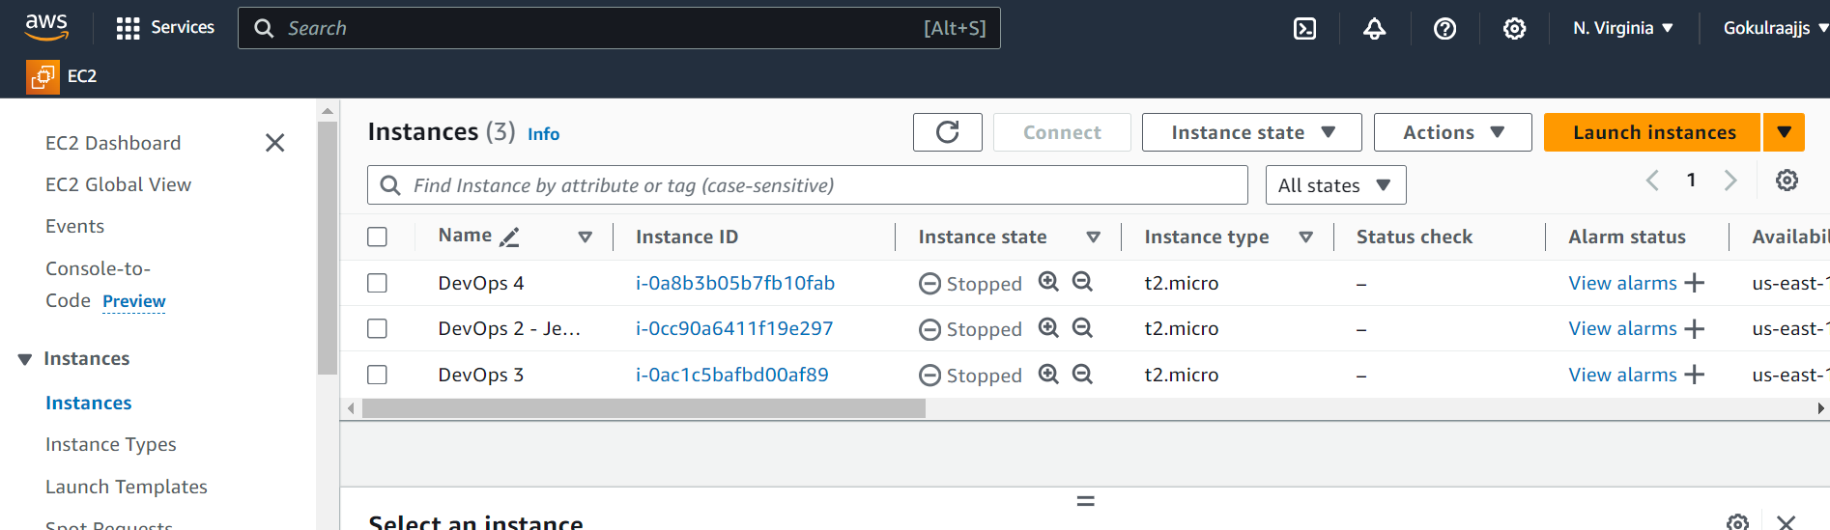

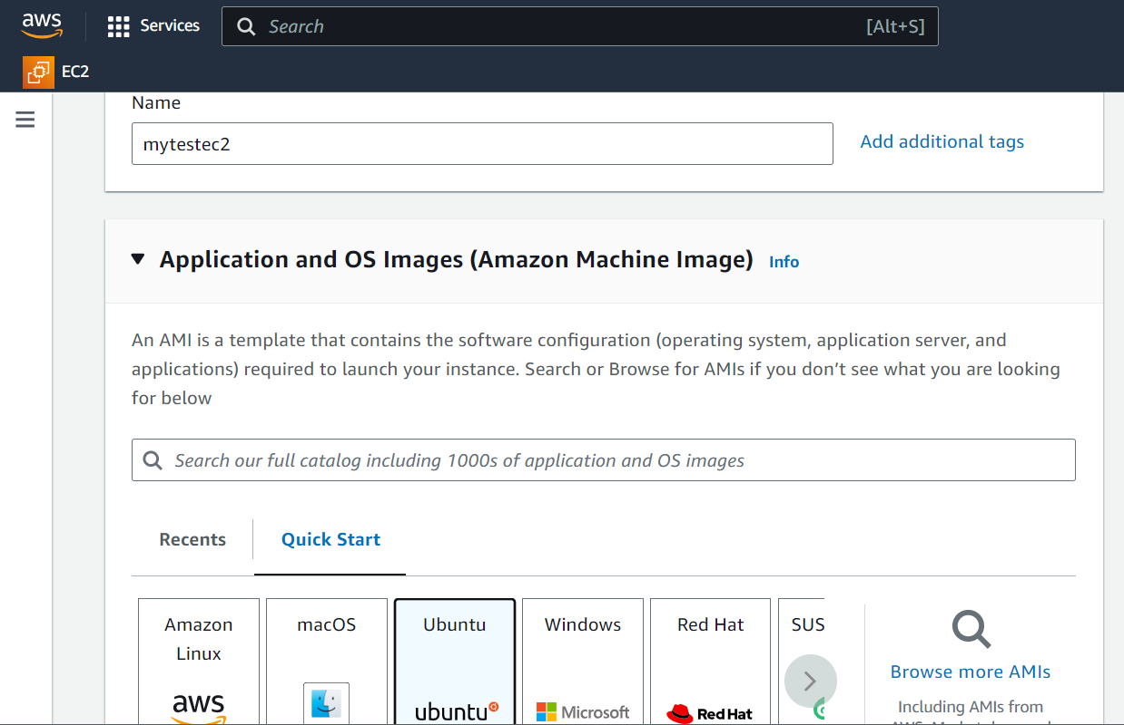

Select the Key pair

Edit the network settings 🡪 Select the created VPC 🡪 Select the public subnet 🡪 launch the instance

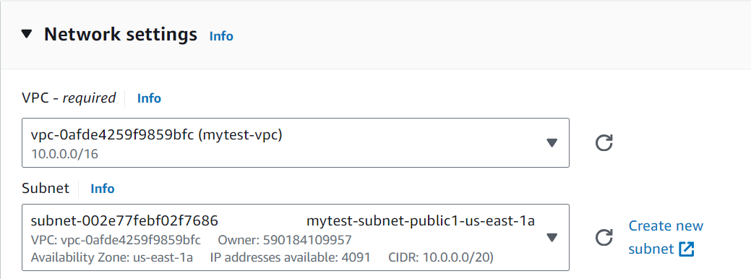

Now an Linux EC2 instance is created in the VPC and the public subnet as below.

